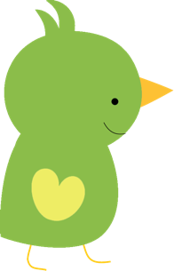

Baby Birds
Schedule

7:00-7:45 | Welcome! Free Play Time
7:45-8:15 | Breakfast & Sign Language
8:15-8:30 | Diapers/ Music & movement
8:30-9:00 | Circle Time
9:00-9:30 | Bottles/ Flashcards
9:30-11:00 | Nap
11:00-11:15 | Diapers/ Fine Motor/ Sensory
11:15-12:00 | Lunch
12:00-12:30 | Outside/ Art
12:30-12:45 | Free play with friends
12:45-1:15 | Bottles/Diapers
1:15-2:45 | Nap
2:45-3:15 | Snack
3:15-4:00 | Diapers/Music & movement
4:00-4:15 | Bottles & flashcards
4:15-6:00 | Free play & clean up

